**SETTING UP SNOWSTORM SERVER**

**GETTING STARTED**

To get started, download/clone the repository at [IHTSDO/snowstorm: Scalable SNOMED CT Terminology Server using Elasticsearch (github.com)](https://github.com/IHTSDO/snowstorm)

Install Docker and Docker Compose

Also we need to set the vm.max_map_count to 262144 by giving the command,

*wsl -d docker-desktop sysctl -w vm.max_map_count=262144*

**STARTING SNOWSTORM**

To set up Snowstorm, go to the directory where you have cloned the repository and run

*docker-compose up -d*

This is start setting up snowstorm server in the docker at <http://localhost:8080> by default.

**UPLOADING THE TERMINOLOGY**

After the snowstorm server is setup, go to the Swagger UI set up at <http://localhost:8080>

Here under the Import Section, create a new import by POSTing the following. Please Refer the images below as well,

{

"branchPath": "MAIN",

"createCodeSystemVersion": true,

"type": "SNAPSHOT"

}

When you click on execute, it will generate an Id like **d7937fe9-04df-4516-af5d-967a42f3e280**

Make a note of this ID generated

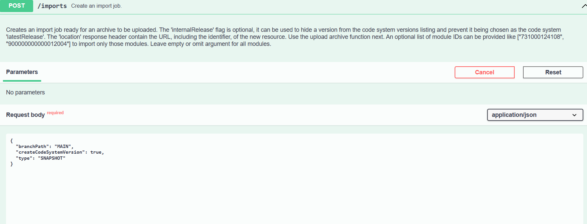

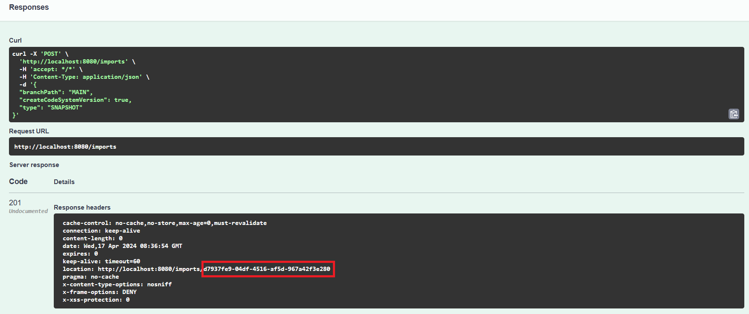

Now, you need to upload the terminology at imports/<import id>/archive endpoint on the UI.

Enter the ID here

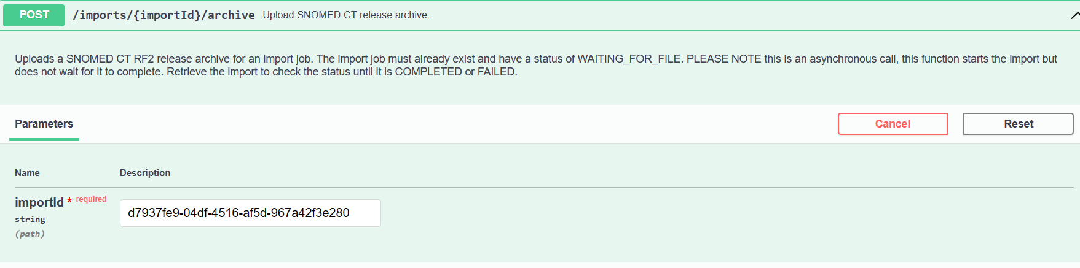

And upload the zip file here and Execute.

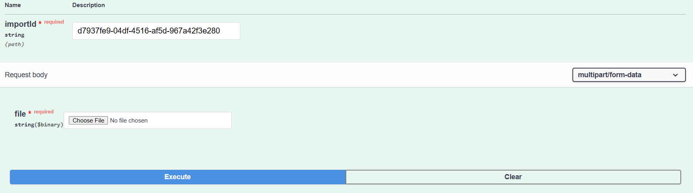

**RETRIEVING SNOMED CONCEPTS**

Once the Snomed terminology has been uploaded , you can query for the concepts as follows.

Retrieving a SNOMED Concept by identifier

[http://localhost:8080/browser/MAIN/concepts/<concept_id](http://localhost:8080/browser/MAIN/concepts/%3cconcept_id)>

This brings in all information about the concept along with its different terms/synonyms.

Retrieving a SNOMED Concept by the term

[http://localhost:8080/MAIN/concepts?term=<name](http://localhost:8080/MAIN/concepts?term=%3cname)>

This allows you to search for the different concepts with the key word of the concept you are looking for. It brings in the concept code for all the concepts relating to that keyword,

Performing ECL queries

You can also perform Expression Constraint Language queries and get their outputs through HTTP requests on

[http://localhost:8080/MAIN/concepts?ecl=<ecl_query](http://localhost:8080/MAIN/concepts?ecl=%3cecl_query)>

**REFERENCES**

[IHTSDO/snowstorm: Scalable SNOMED CT Terminology Server using Elasticsearch (github.com)](https://github.com/IHTSDO/snowstorm)

[snowstorm/docs/loading-snomed.md at master · IHTSDO/snowstorm (github.com)](https://github.com/IHTSDO/snowstorm/blob/master/docs/loading-snomed.md#via-rest)

[snowstorm/docs/updating-snomed-and-extensions.md at master · IHTSDO/snowstorm (github.com)](https://github.com/IHTSDO/snowstorm/blob/master/docs/updating-snomed-and-extensions.md)

[snowstorm/docs/using-the-api.md at master · IHTSDO/snowstorm (github.com)](https://github.com/IHTSDO/snowstorm/blob/master/docs/using-the-api.md)

[snowstorm/docs/getting-started.md at master · IHTSDO/snowstorm (github.com)](https://github.com/IHTSDO/snowstorm/blob/master/docs/getting-started.md)